**CyberSec – Blogs and Bombe**

**Abstract**

**BLOGS**

Cybersecurity is ever updating domain. We need to get constantly updated about the new technologies coming in. This project comes with blog creation in which users can write and update their blogs. There are different categories such as Networking, Security, Cutting edge technologies, Cybersecurity Awareness and tools, etc. Blogs can be written on any of these sections. These blogs can be monitored and managed by admin.

**BOMBE**

Our present generation is obsessed with security of data that’s being exchanged digitally through different platforms. In order to maintain confidentiality, Integrity and accessibility (CIA Triad) we need good techniques. Steganography is the art of concealing information and Cryptography is an advanced mathematical approach to encrypt the data. One method covers the limitation of the other. The message can be encrypted using cryptographic algorithms and can safely be hidden using steganography. These well known techniques of data security keep the message to be delivered confidential and unaltered.

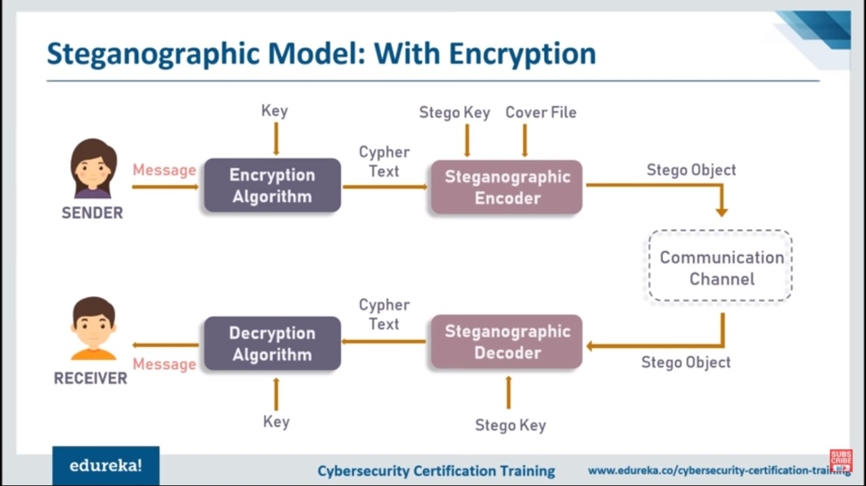

In this application the message to be encrypted and cover image are taken as inputs. Here we use Affine cipher and Caeser cipher (hybrid cryptography) as cryptographic algorithms. The Steganographic algorithm used is LSB (Least Significant Bit) algorithm. Data to be encrypted is taken as input and cover image is also taken for Steganographic image encoding. First the data goes through affine cipher encrypting and now the encrypted text goes to Caesar cipher for level-2 encryption. This cipher text is taken as input string for the image and stego-image is generated. The image acts as perfect cover for the message. When the stego-image is decoded, cipher text is obtained. 2-level Decryption of this cipher text lets the intended message to be revealed. This application produces the image that contains cipher text as output during encoding phase and decoded message as output in decoding phase.